Electronic Configuration
Name: |  |  | Use in Conjunction with class powerpoint
Class: |  |  | Nelson Textbook: pp: 113-118
Period: |  |  | Review Questions 1.4
Date:
Electron Configuration Revision
Multiple Choice
Carefully read each question and then circle the letter of the correct answer.
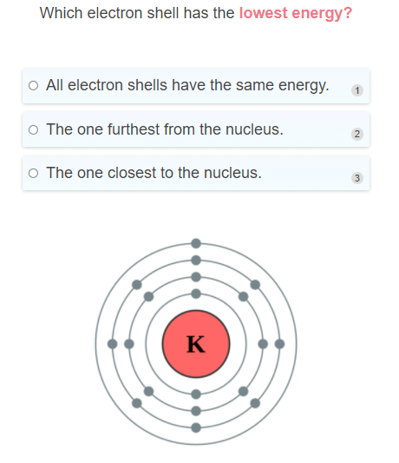
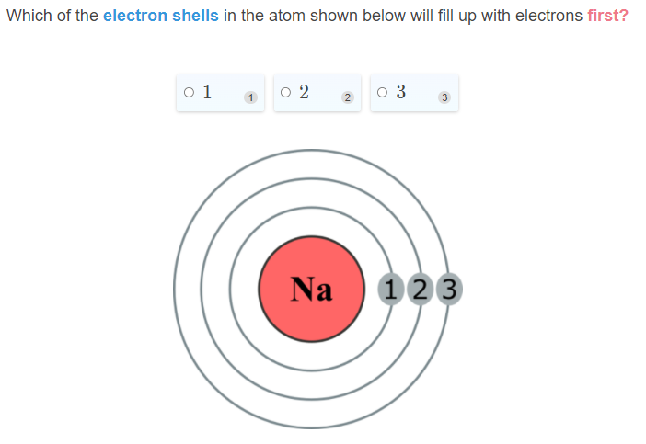
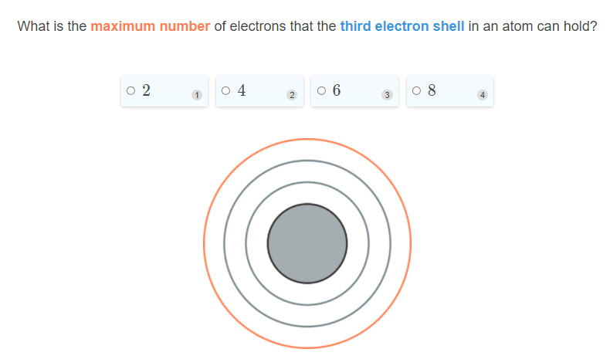
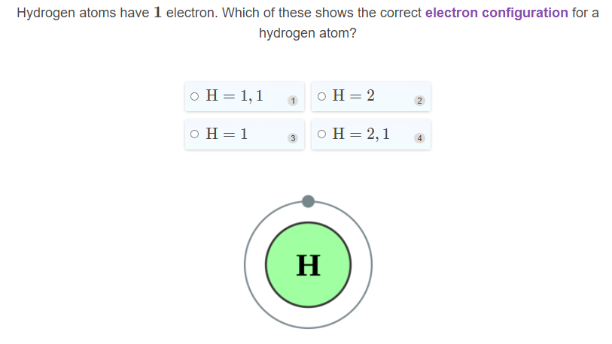
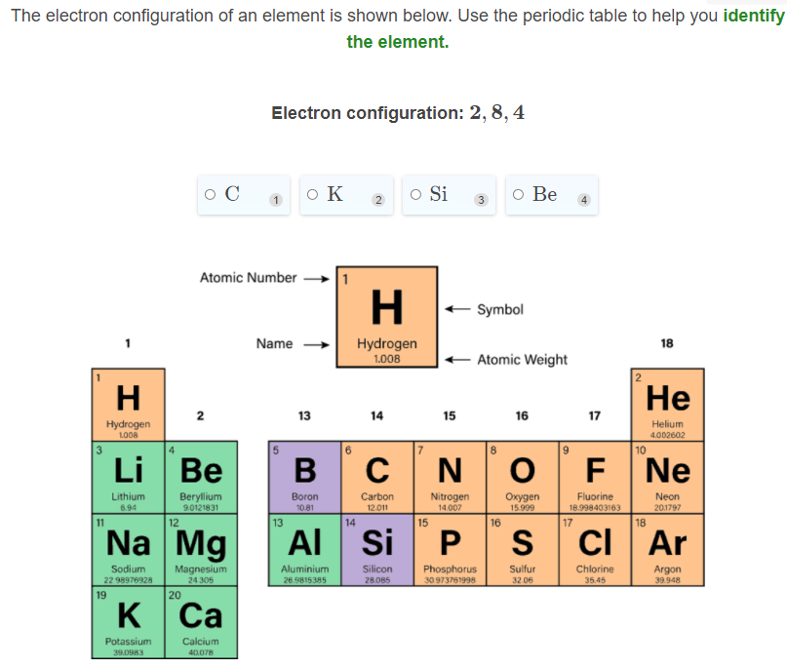
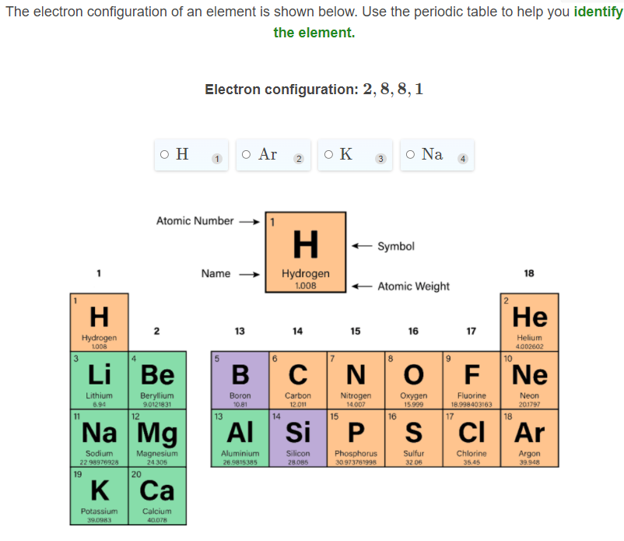
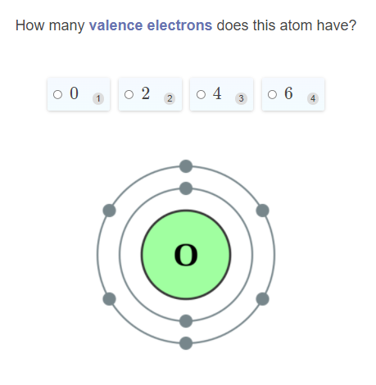
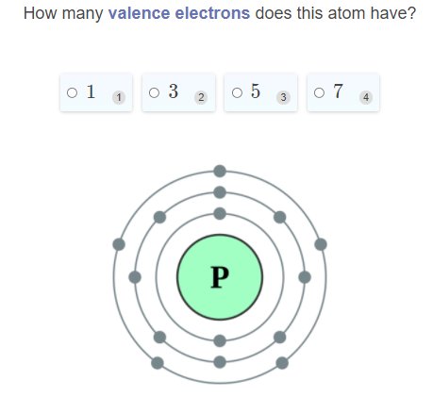
Short and Long Answer
- A neutral atom of nitrogen has 7 electrons. Draw the electrons in their correct places in the diagram below. Use black dots or crosses to represent electrons.
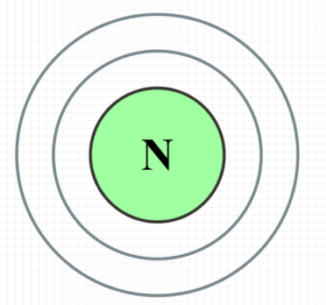

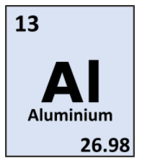
- The element box of alumi nium is shown to the right. Use this to work out how many electrons are in a neutral atom of aluminium, then draw the electrons in their correct places I the diagram below. Use black dots or crosses to represent electrons.

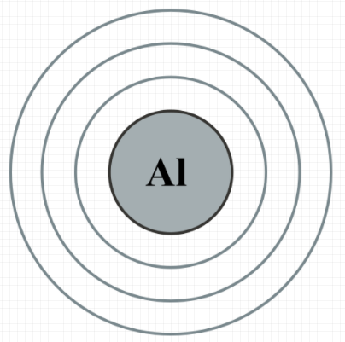

- Write the electron configuration for the atom shown below,

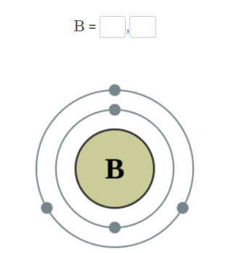

- Using oxygen and neon as examples, explain the importance of valence electrons.

In your answer you should:
- Define valence electrons.
- State how many valence electrons are in each atom of oxygen and neon.
- Describe the relationship between the number of valence electrons an element has and its position on the periodic table.
- Compare the reactivity of oxygen and neon.

Electronic Configuration of Atoms
Multiple Choice
Carefully read each question and then circle the letter of the correct answer.
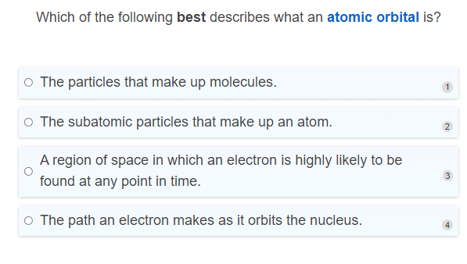
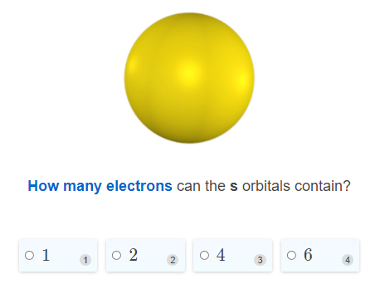
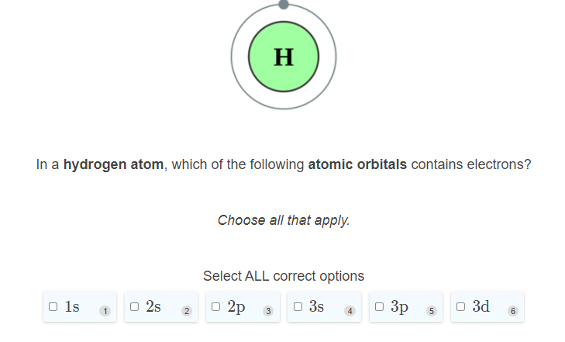
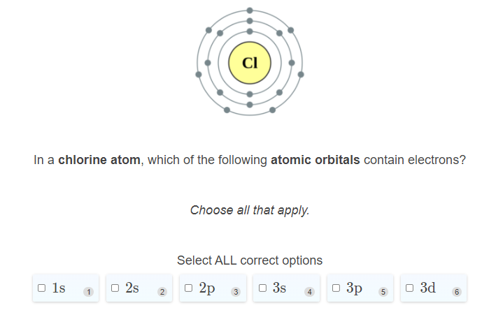

Short and Long Answer

- Select the correct words to fill in the spaces below.
p orbitals 2 s orbital s orbital 8 p orbitals s orbitals d orbitals
The first electron shell contains only one ____________ and so can contain ____________ electrons. The second electron shell contains one _____________ and three _____________ and so can contain a total of ______________ electrons.
The third electron shell contains one ______________, three ____________ and five ____________ and can therefore contain a total of 18 electrons.
- Place the orbitals in order of lowest to highest energy.
4s 4 p 3d 3p 3s
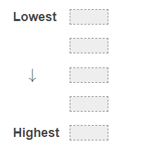

- The atomic number of silicon is 14. What is its electron configuration, using Madelung’s Rule?

- Explain why electrons usually fill the 4 s atomic orbital before filling the 3 d atomic orbitals. Also explain which two elements are the exception to this rule, and why.

Electron configuration of Ions
Multiple Choice
Carefully read each question and then circle the letter of the correct answer.
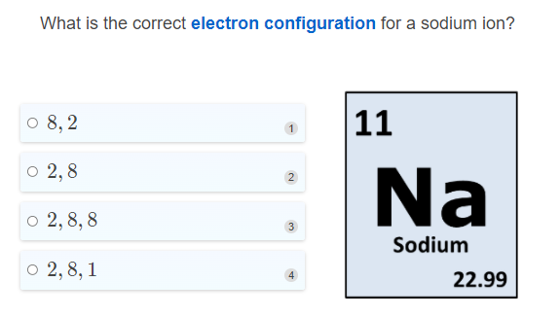
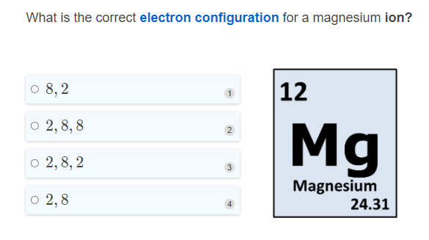
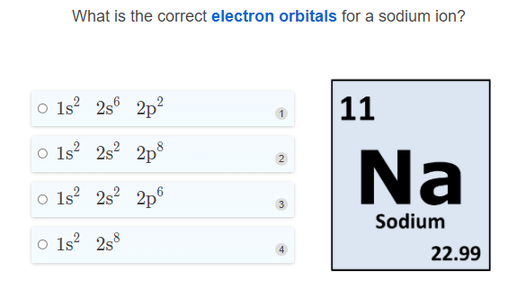
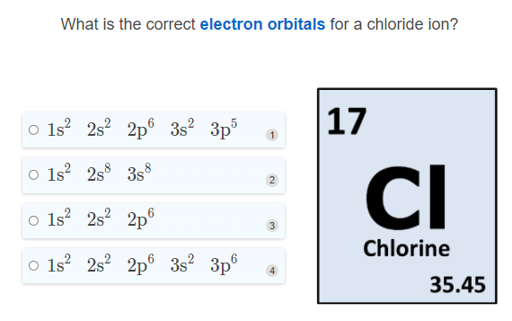
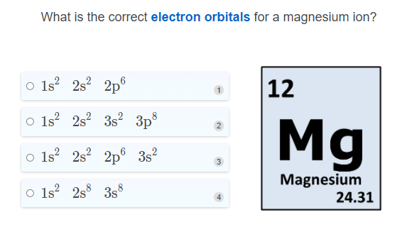

Short and Long Answer

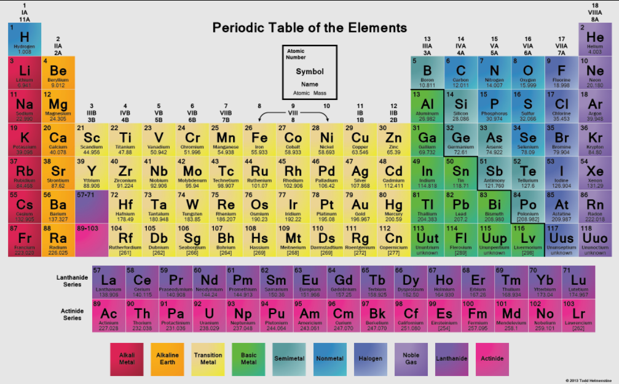
- Oxygen's atomic number is 8. What is the electron orbital configuration of the oxide O ²⁻ anion?

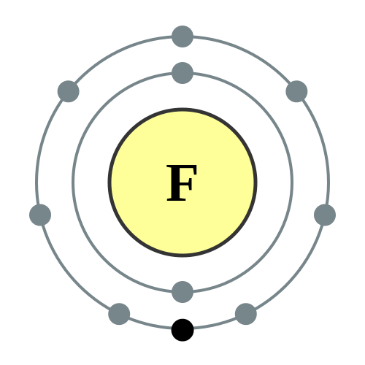

- Fluorine's atomic number is 9. What is the electron orbital configuration of the fluoride anion (F -)?

- Sulfur's atomic number is 16. What is the electron orbital configuration for the sulfide anion (S²⁻)? 

